**St Peter’s Institute of Pharmaceutical Sciences**

**Course: Bachelor of Pharmacy**

**Subject: Pharmaceutical Biotechnology**

**Subject Code: BP605T**

# FERMENTER

**Fermenter:** is a vessel to carry out fermentation. It is quite complicated in design to monitor various facets of microbial growth. It is designed in such a manner that it provides the best growth and production. It provides the ease of manipulation all of the operations associated with the use of fermenters.

**Operation of fermenter**: The different aspects of the fermenter are

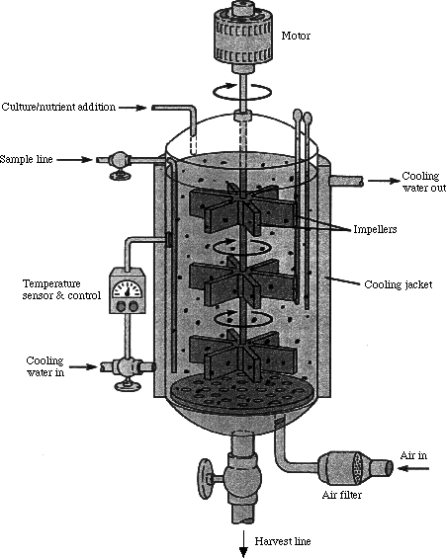(i) size (ii) mixing (iii) aeration (iv) foaming (v) temperature (vi) pH (vii) sterilization of media (viii) corrosion & pressure .

**i. Size**: Fermenters are of varying sizes. It is stated based on the total volume capacity. Operating volume is different from actual volume. “Head space” is allowed for splashing, foaming or aeration of liquid. Usually head space is fifth to quarter of the volume. Fermenters are classified into Lab scale, pilot scale and large scale.

**Lab scale** is of low volume (less than 15 liters). It is used for research and studying various parameters affecting the fermentation process and inoculum development.

**Pilot scale** is intermittent to lab and large scale. It is of medium volume. It is mainly used for scale-up of the process. Pilot scale is similar to large scale in all aspects except size. Sometimes it is used for inoculum development.

**Large scale** is used for actual production at commercial scale. It is of great volume.

**ii.Mixing**: Mixing is required for uniform dispersion of cells, nutrient and oxygen supply. Impellers are used for this purpose. Impellers are of different size and shape. Impellers are attached to shaft either from top or bottom and are driven by motor or magnet. Number of impellers; distance from the bottom and walls; distance between the impellers; number of blades are optimized in accordance with the size, volume of the fermenter.

**Vortex** formation during mixing is a big problem. Vortex in the media creates laminar flow; by this there is improper mixing. **Baffles** are placed inside of the fermenter to overcome the vortex formation.

**iii.Aeration**: Aeration is required for some fermentations. Air is supplied with the help of sparger. Sparger is a porous device used to supply gas. Bubble size depends on the porosity of the sparger. Large bubble escapes easily into the head. Smaller bubble size increases the surface area for exchange of gases. Small bubble size means less porosity of the sparger and clogging becomes a problem. Usually bubble size is fixed but flow rates are altered to suit the requirement of the aeration. Speed of aeration is called flow rate and are measured in volumes of air per volume of medium per minutes.

For sterile air bacterial proof filters are used and for non-sterile air; air passed through glycerol or oil is used. Sparger is connected to this air supply and the flow is monitored.

Vortex formation is a problem for exchange of gases and this can be avoided by use of baffles. Sometimes mild mixing is sufficient for some fermentations and this can be achieved by just aeration. Here in this case no impellers are specially required.

All the air supplied into the fermenter will escape into the head space. Gas is also evolved in some fermentation. Aerosol and a positive pressure are always generated by aeration and agitation. So, fermentation tanks are never sealed tightly for the escape of gases. But contamination may occur during draining and if the organism used in fermentation is pathogenic then special care must be taken.

**iv.Foaming**: Foam is usually generated by aeration and agitation. Foam is a problem with media containing high amounts of peptides and proteolytic bacteria (may be a contaminant). Foam obstructs the agitation process and exchange of gases is a limitation. Foam is forced out of the fermenter and by media is lost or may lead to contamination.

Foam is controlled by **mechanical or chemical** methods.

Mechanical impellers are placed on the head space to break up the foam.

In chemical method, a suitable antifoaming agent is included in the medium to control the foam. There are two types of antifoaming agents. They are inert inorganic antifoaming agents and organic antifoaming agents.

Inorganic antifoaming agents are silicone substances. They are cost and can be added initially into the medium and can be sterilized along with the medium.

Organic antifoaming agents are crude organic animal and vegetable oils like lard oil, corn oil, soyabean oil etc. or long chain alcohols or octaldehyde etc. or mixtures. They are not inert; they are toxic; they act as nutrients; they alter the pH of the medium; they are sterilized separately and mixing with the medium is a problem. They are usually added during the process either manually or automatically with the help of sensors that sense the foam generation.

**v.Temperature**: Optimum temperature is required for maximum growth of microorganism during fermentation process. Or sometimes metabolically active microorganisms evolve heat. So, either increase or decrease in temperature is required. This is done by using jacket system or retention tubes within the fermenters. Steam, hot water or cold water is circulated to monitor the temperature in the fermenter.

**vi.pH**: optimum pH is required for maximum growth of microorganism during fermentation process. Or sometimes pH is altered during the fermentation process. So, either increase or decrease in pH is required. This is done by using buffering medium or addition of an acid (0.1N HCl) or base (0.1N NaOH). pH of the medium is recorded continuously using sensors and suitable quantity of acid or base is released from the reservoir connected to the fermenter.

**vii.Sterilization of medium**: to carry out fermentation using pure culture requires media to be sterilized. Large quantities of media are sterilized using retention tubes. Usually concentrated medium is sterilized in the retention tube where media is passed through tubes and steam in opposite direction. The medium is sterilized and cooled by the time it reaches the fermenter. Concentrated medium is diluted with sterile water in the fermenter. Overcooking of the medium is avoided, because overcooking causes caramalization of sugars, generation of free radicals and decrease in pH.

Sterilization of the medium is not required for some fermentations like yeast fermentations where low pH is used; fermentations where rare carbon sources are used like hydrocarbons, methane gas etc.; fermentations using massive inoculum; fermentations using toxic materials etc.

**viii.Corrosion & pressure**: Corrosion is a problem where the material of the fermenter is eroded away. Example: lactic acid fermentation and tetracycline fermentation where high salt concentration medium is used. To avoid corrosion fermenters are made up of metals that are resistant to corrosion.

**References**

1. U.Satyanarayana. (2005).Text book of Biotechnology,pp.245-246.